Name: ___________________________________

Investigation 3: The Force of Magnetism
Focus Question Answers and Study Guide

Part 1: Magnets and Materials

Focus Question: What materials stick to magnets?

Metal items made of iron or steel (which has iron in it) stick to magnets. Not all metals stick to magnets, though. Brass, aluminum and copper do not stick to magnets. Other materials like plastic and wood also do not stick to magnets.
*So not all metals attract to magnets, but all metals are excellent conductors of electricity.

Part 2: Magnets Interact

Focus Question: What happens when two or more magnets interact?

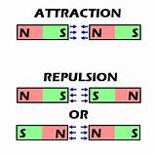
Every magnet has a north (N) and a south (S) pole. When opposite poles touch each other (N-S or S-N) magnets attract. When same poles touch each other (N-N or S-S) magnets repel.

Part 3: Magnetic Fields

Focus Question: What happens when a piece of iron comes close to or touches a permanent magnet?

*When a piece of iron (or steel) comes close to a magnet, it begins to attract, and you can make it hover towards the chair like we did with the paper clip attached to a string (induced magnetism). This happens because every magnet has an invisible magnetic field.
*When a piece of iron (or steel) touches a magnet, it becomes a temporary magnet that can attract other iron or steel objects. You can form a chain as long as the items are not too heavy. This happens because the poles of the magnet temporarily make the ends of the iron/steel objects have north and south poles, or become magnetized. (This is also induced magnetism. Induce literally means to make something happen.)

Part 4: Magnetic Force

Focus Question: What happens to the force of attraction between two magnets as the distance between them changes?

Magnetic force can work through things. Magnets can attract through any material as long as it is thin enough and as long as it isn’t too heavy. We tested how the distance between two magnets affects the force of attraction by putting plastic spacers between the magnets and the cup on our balance. We learned that as the distance (thickness) between 2 magnets increases (because we put plastic chips there), the force of attraction decreases. If you want to strengthen the magnetic force, you would need to add magnets. Earth has a magnetic field that not only attracts magnets, but can also magnetize iron and steel objects over time.

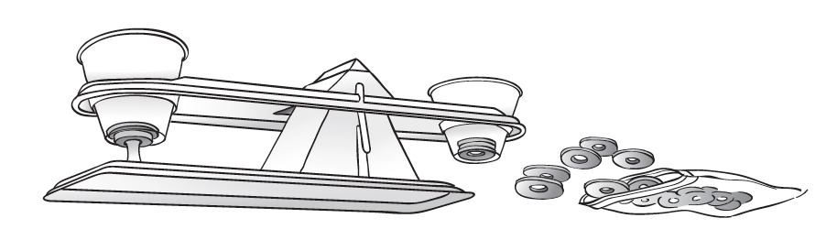

Other things to know for written responses:

1. Be prepared to explain how to create and electromagnet. Tell what supplies you need and how to put them together.

2. Be prepared to explain why a magnet can form a chain and can pick up a series of iron/steel objects. This is induced magnetism. Key things to include are that the first iron object touching the magnet becomes a temporary magnet, which then makes each iron object in the chain become a temporary magnet. You can put quite a few objects in the chain as long as they are not too heavy (or if you have a very strong magnet.)

